
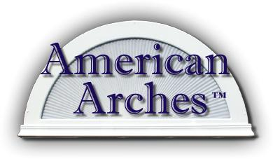

Custom Selections
(Manufactured to any shape or size)
All arches and eyebrows can be inside mounted with mounting strip

Custom Non-movable Arches & Eyebrows
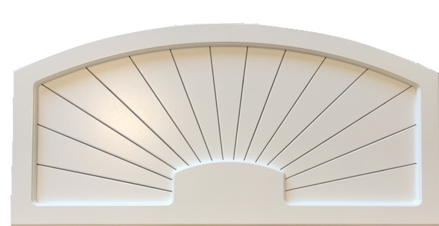
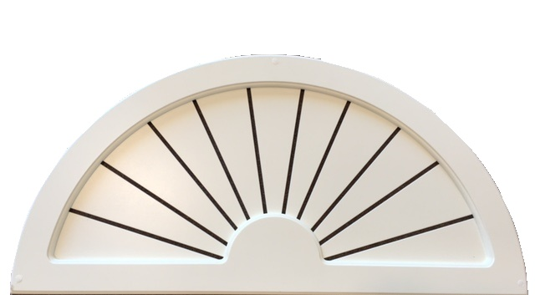
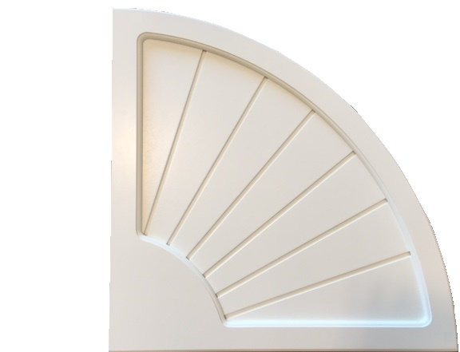
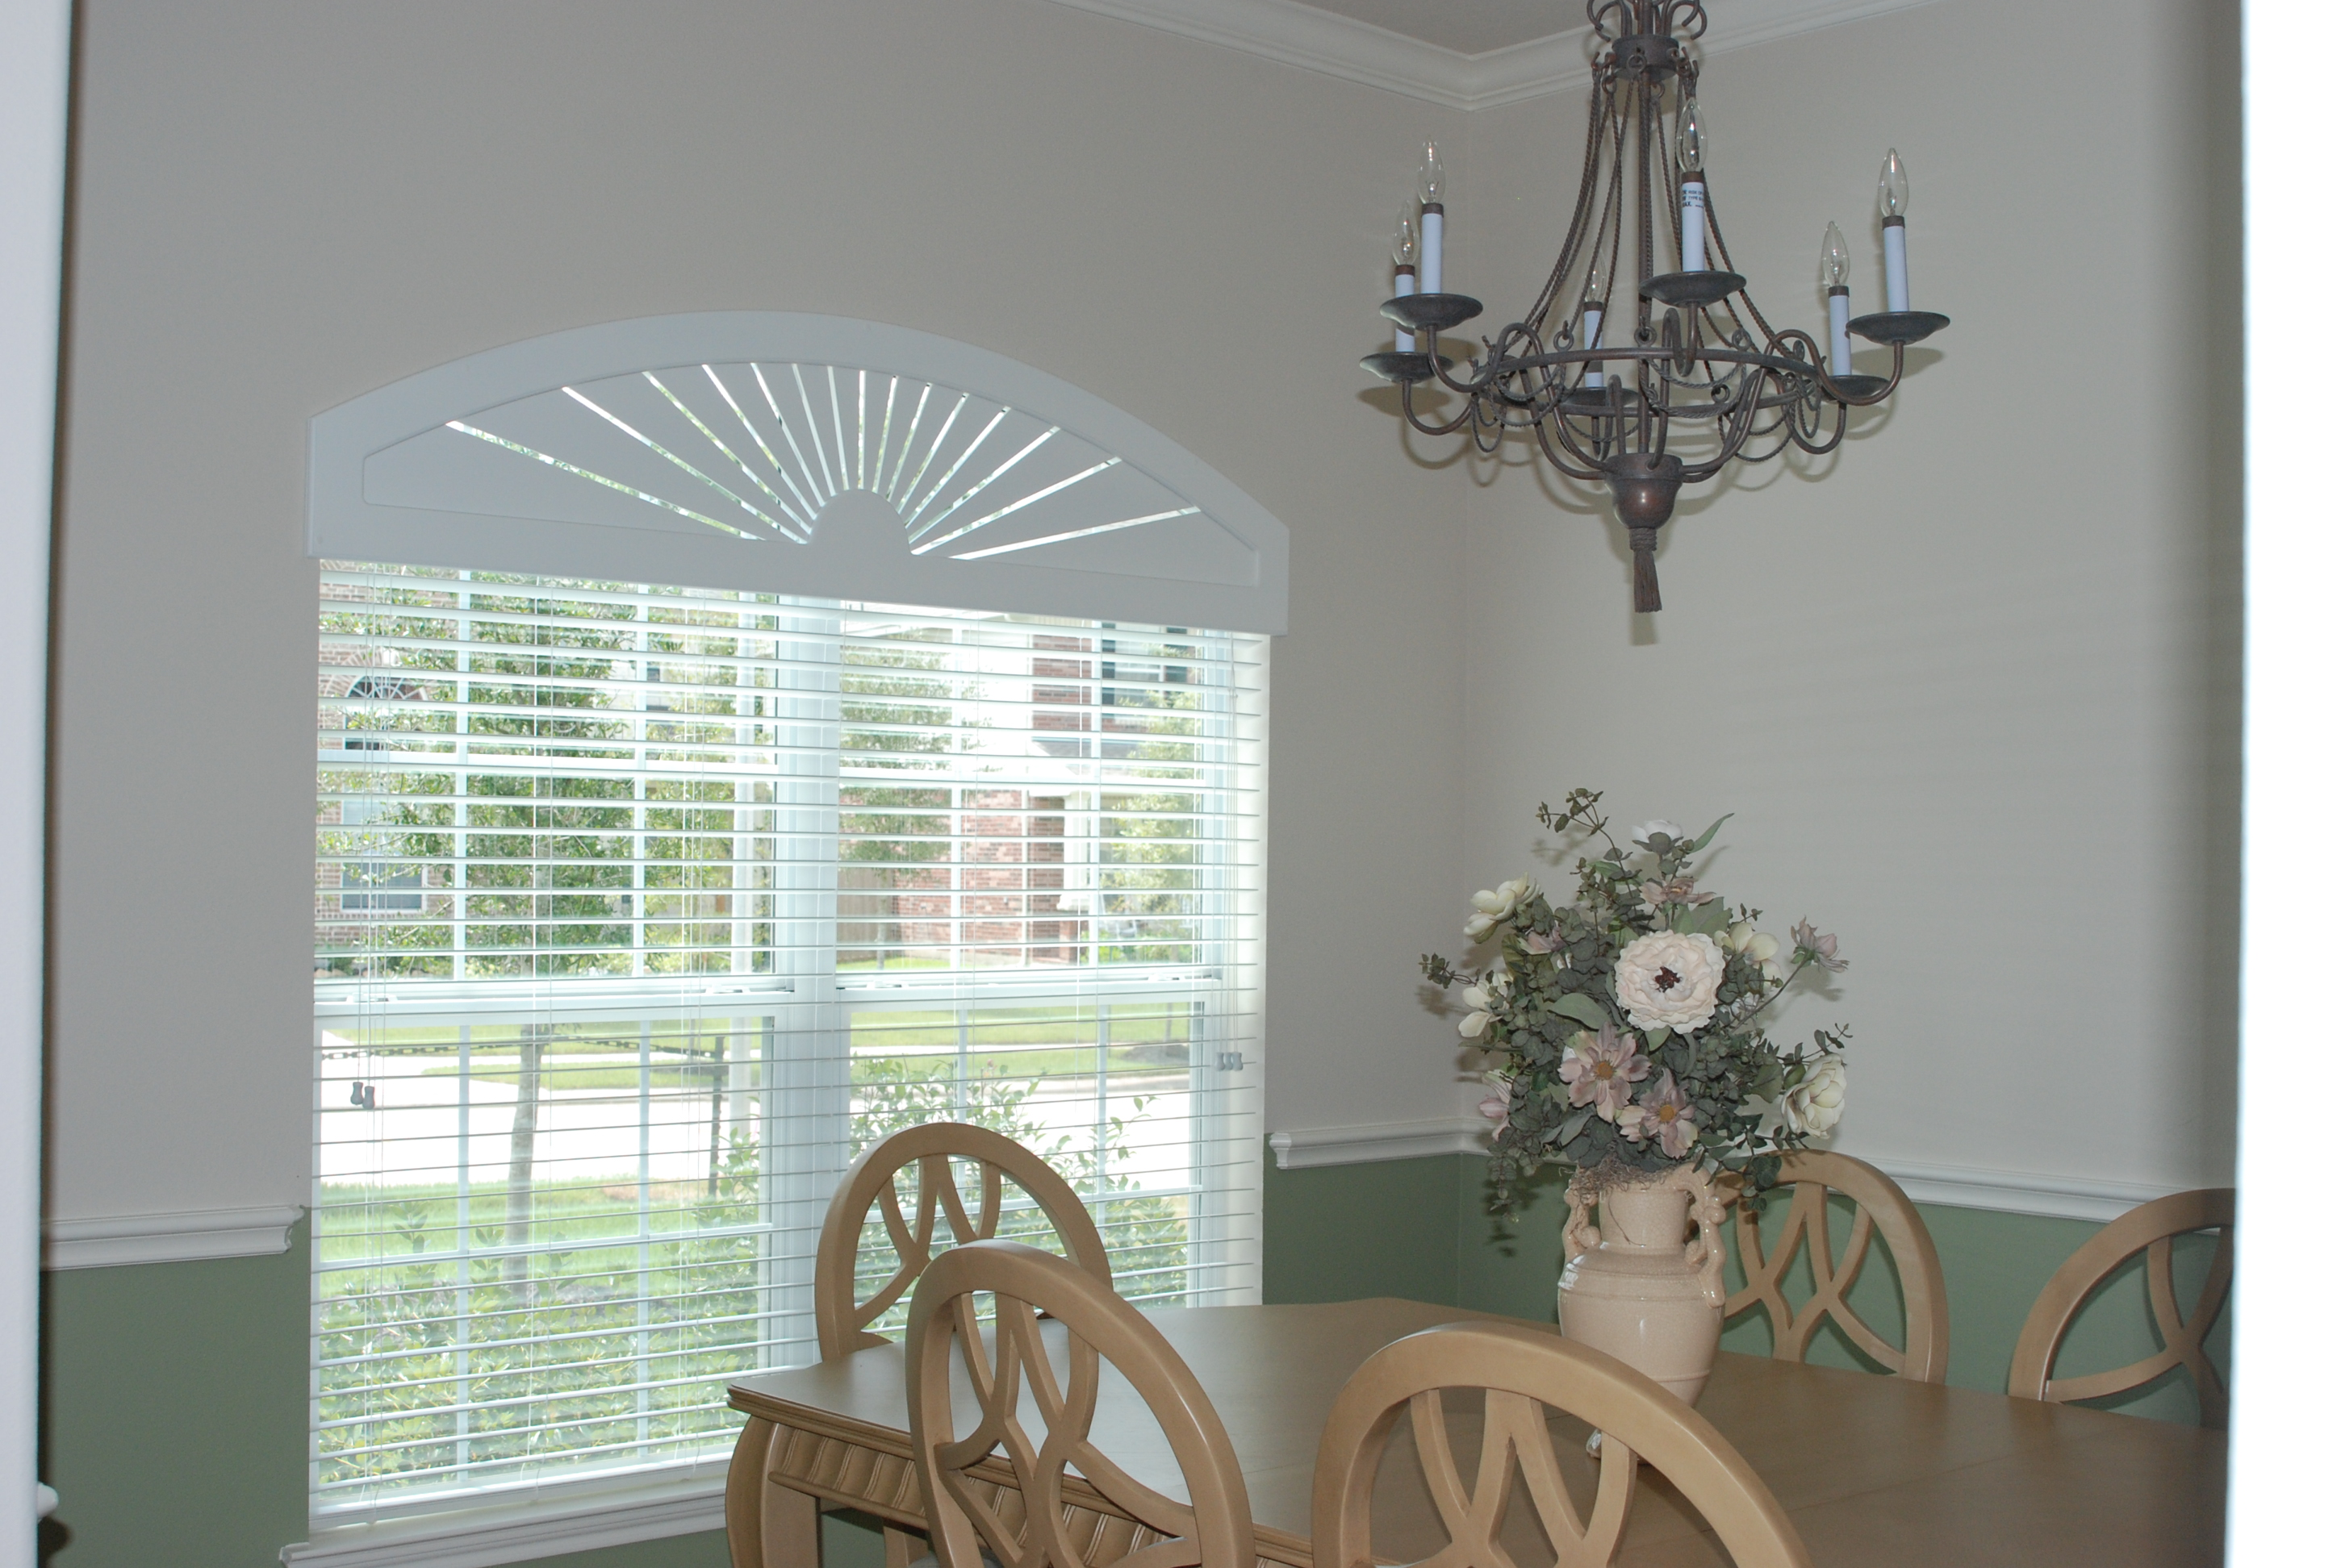
3 dimensional framed design

Sunburst Arches (More light) used for north and south facing windows
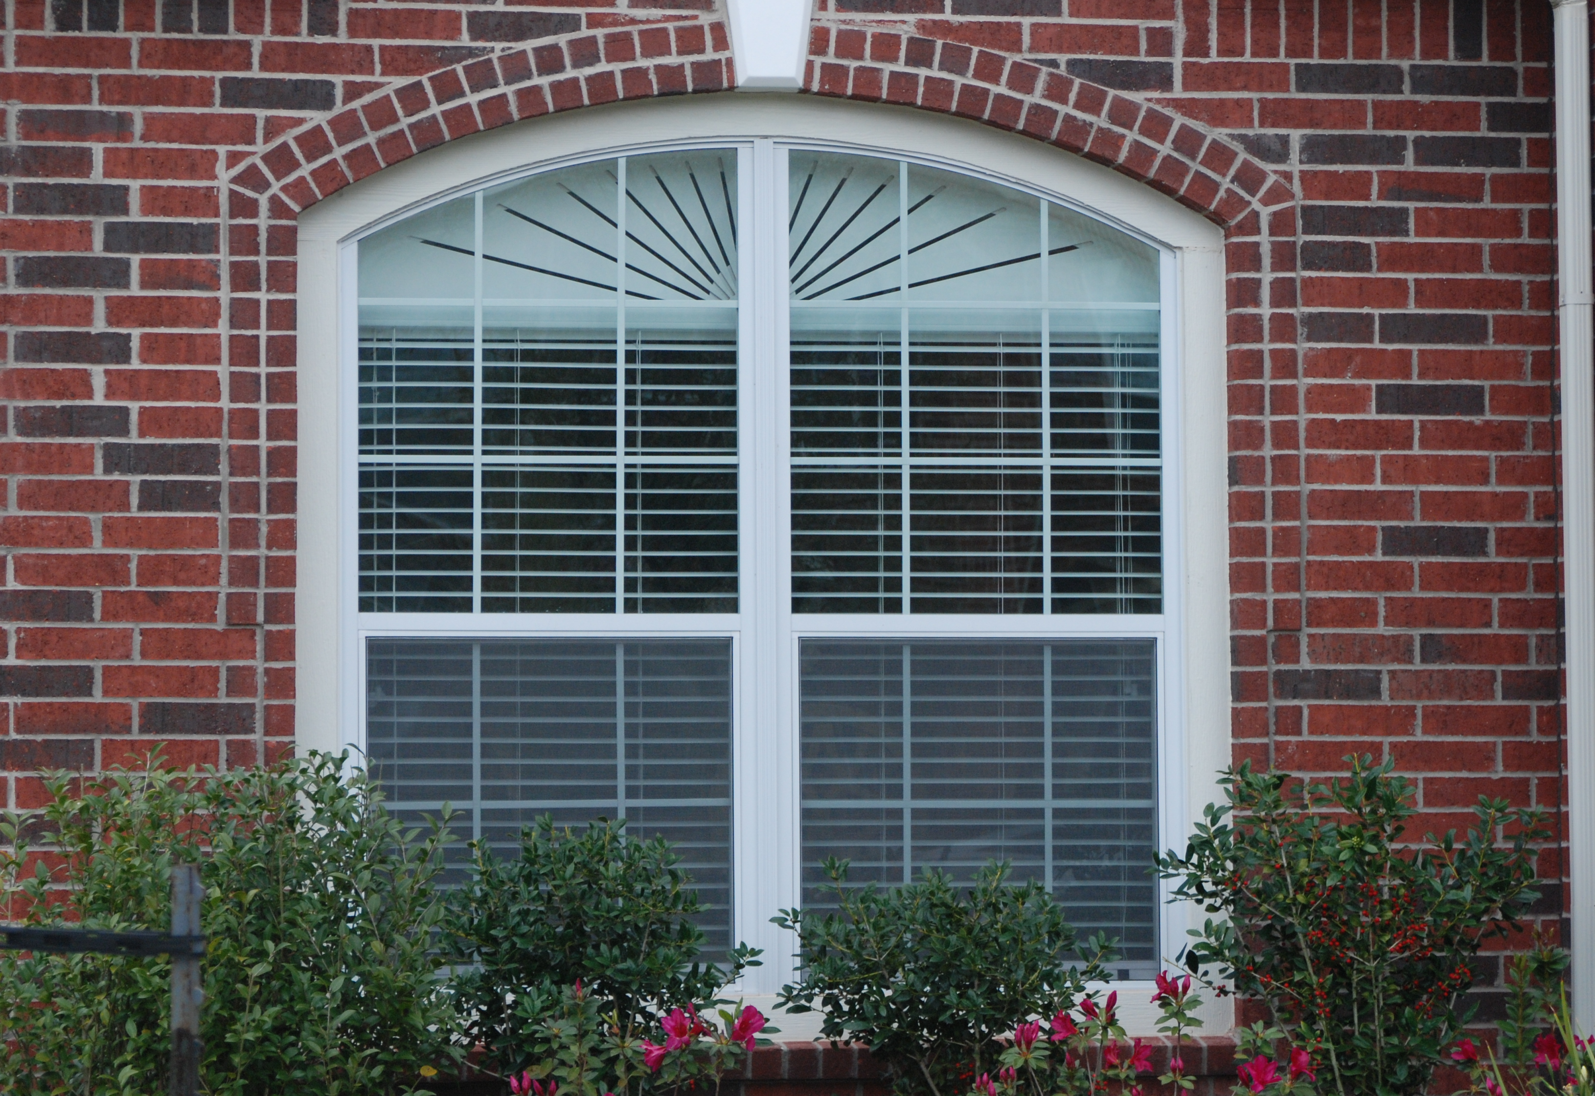
1/4" openings between slats, block’s approx.
85% of direct sunlight
Slatburst tm Arches (Less Light) generally used on east and west facing windows
1/8" angled openings between slats, block’s approx.
92% of direct sunlight
Blackout Arches (No light) used in bedrooms, bath and TV rooms
Resembles the Sunburst but the grooves are not
cut all the way through
100% energy efficient, a great treatment to darken any room
Custom Operable Arches & Eyebrows
Operable Slatburst Fully adjustable large Slats (less Slats to adjust)
All operable arches over 48" have center support
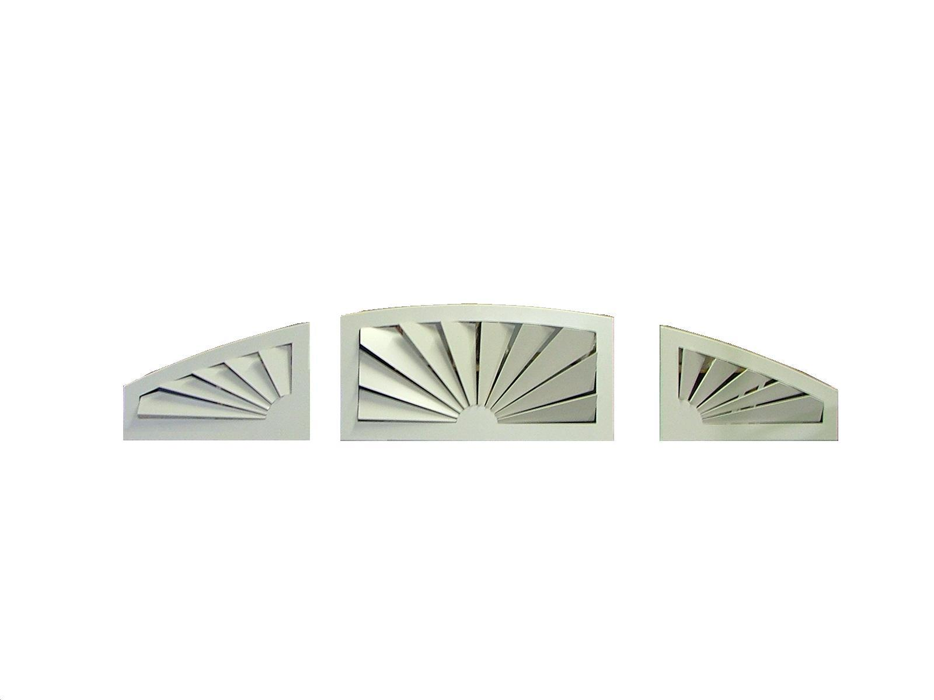
All operable arches over 59" will be in two parts, easy to assemble with our new tongue and grove design

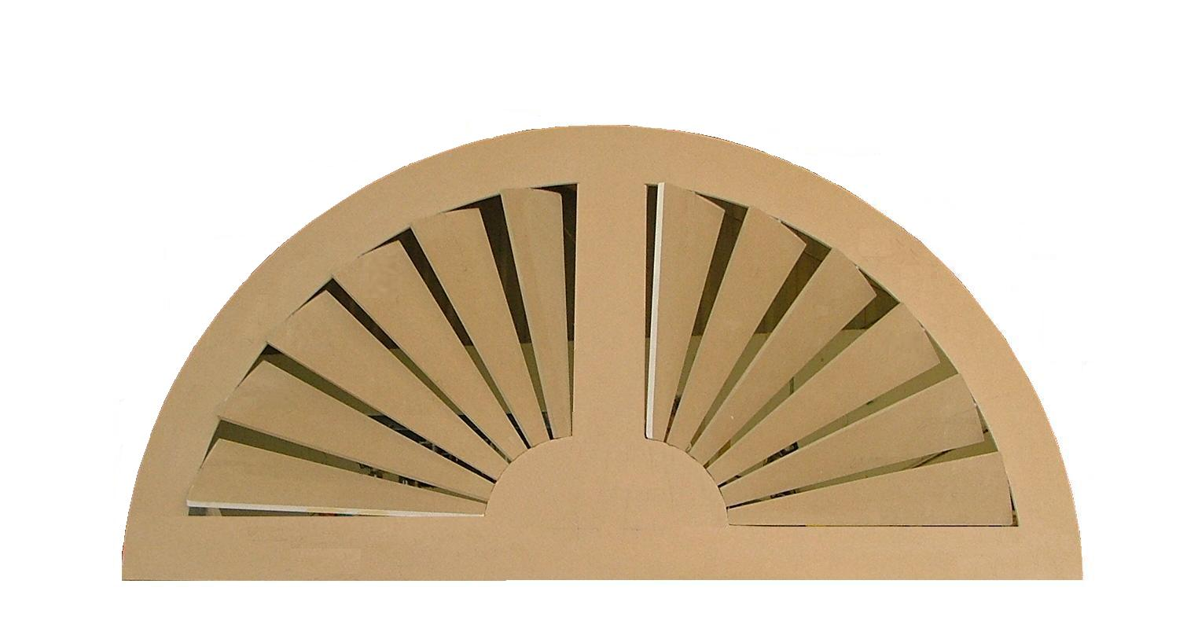
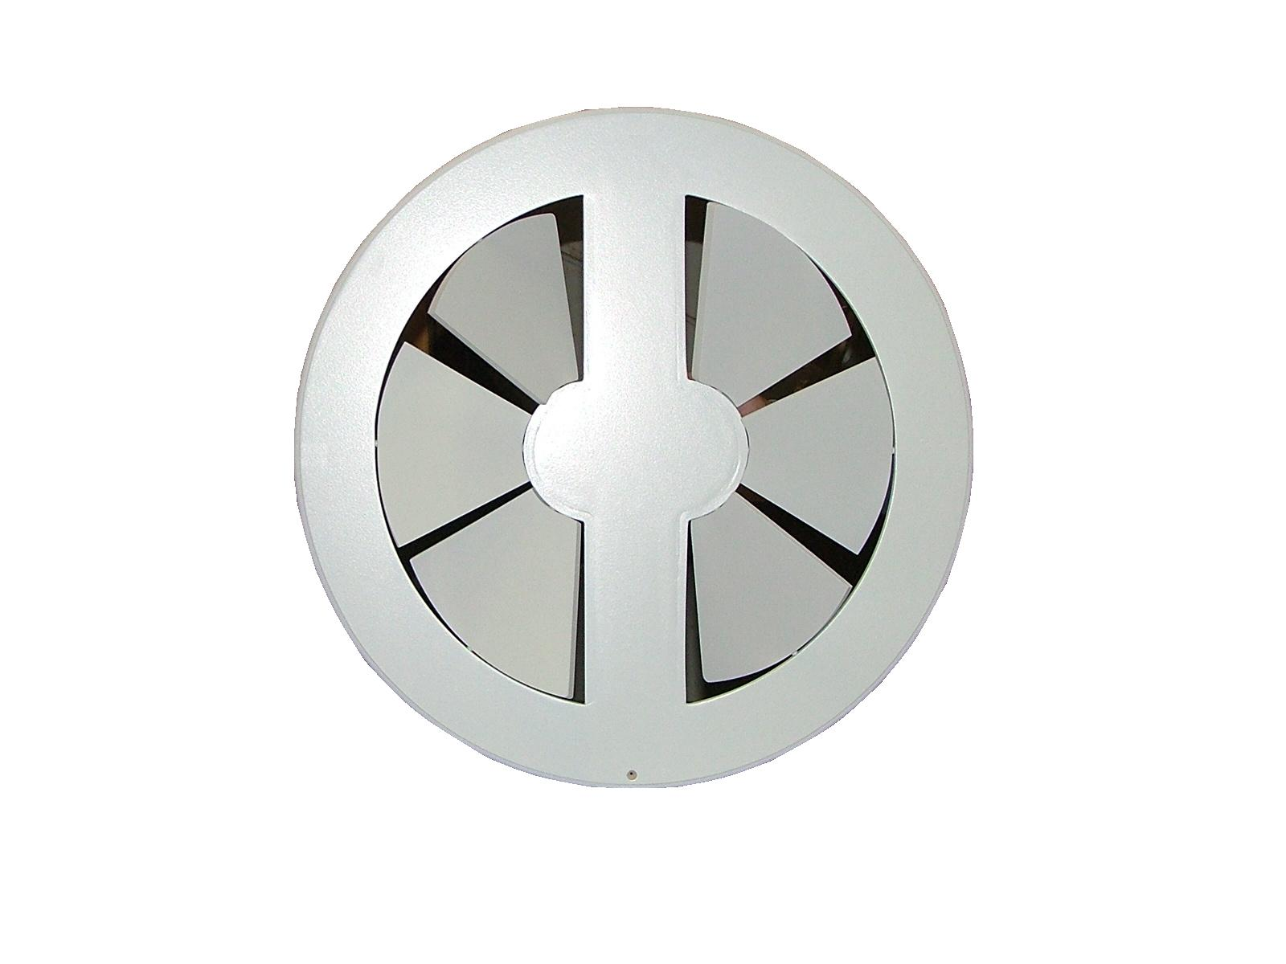
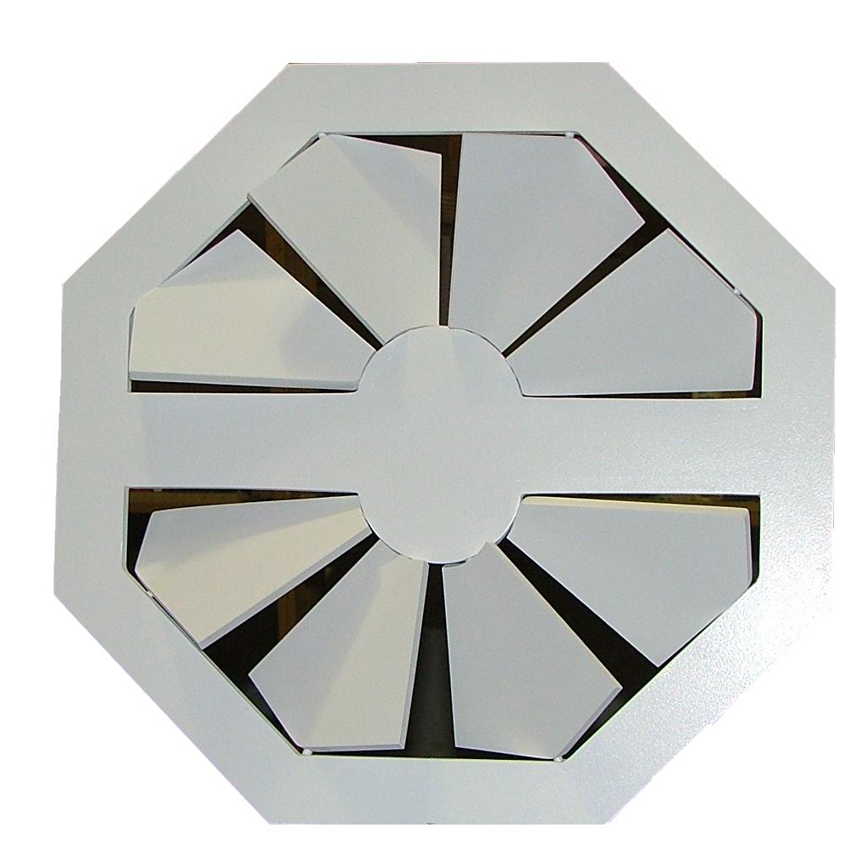

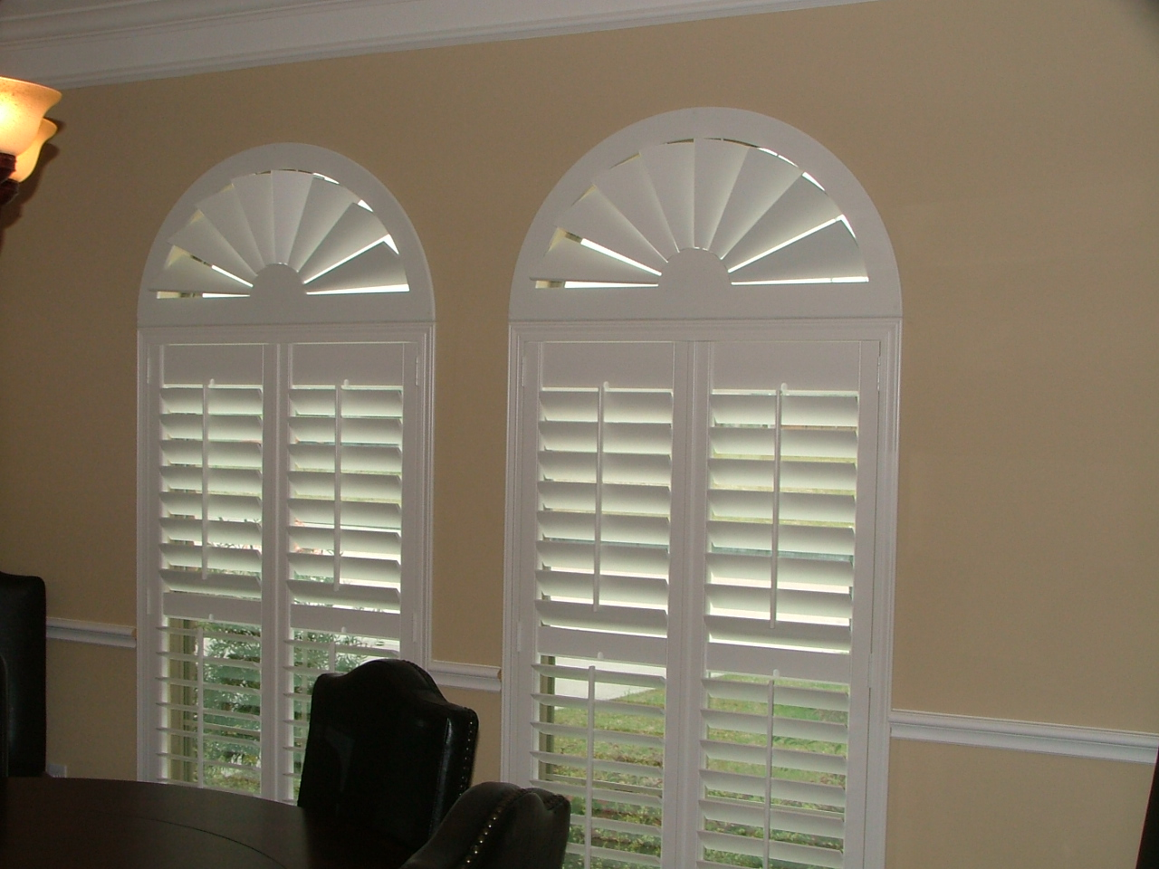
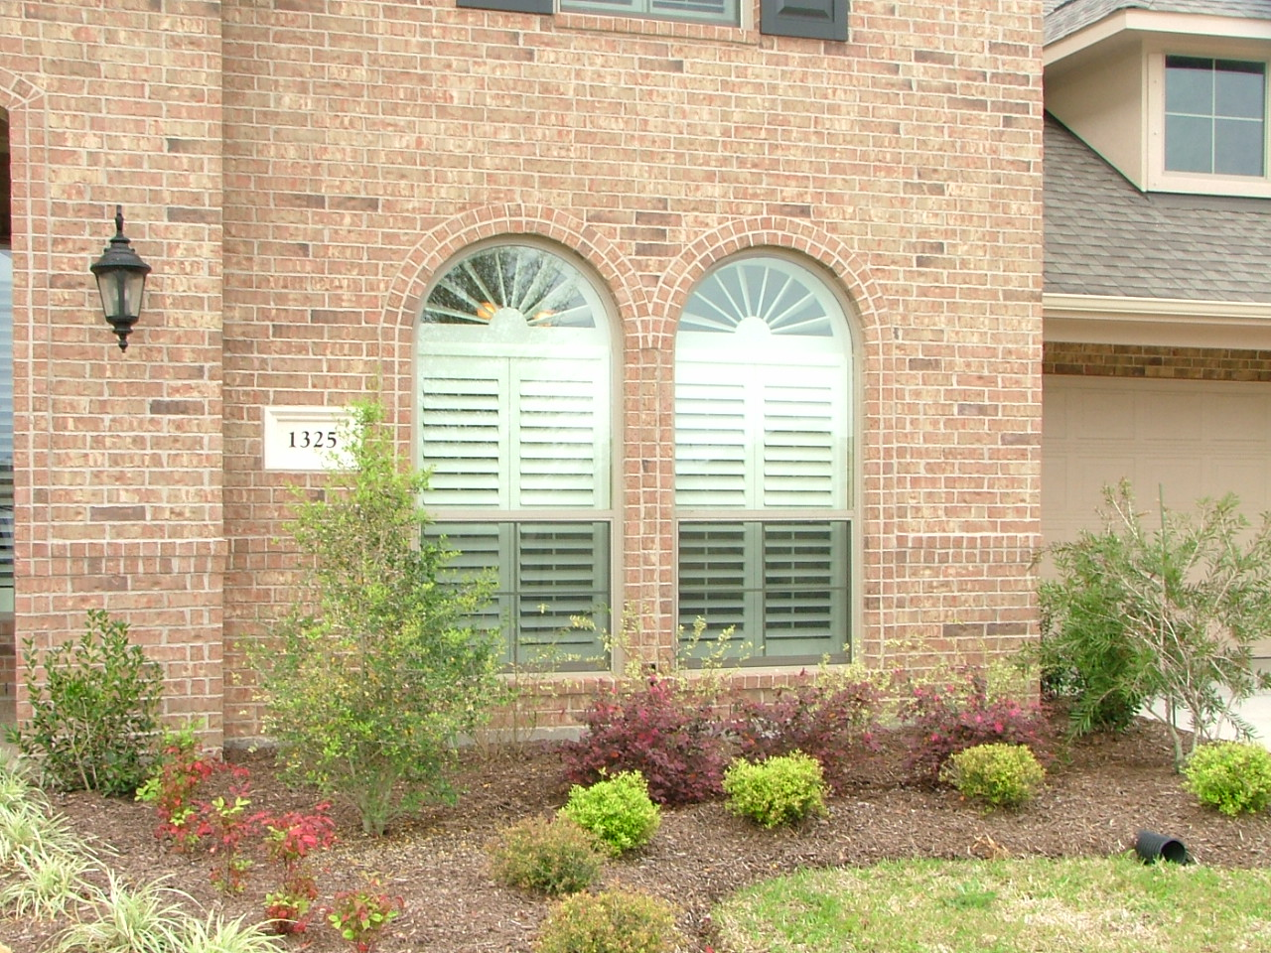

For Commercial use, all products can be manufactured with SierraPine flame retardant MediteFR where Class 1 flame retardant material is required. For additional information contact sales@americanarches.com

Stock Selections

King Stock Movable Arches and Eyebrows
Made to stock specifications, if they fit, they ship, made "On Demand"
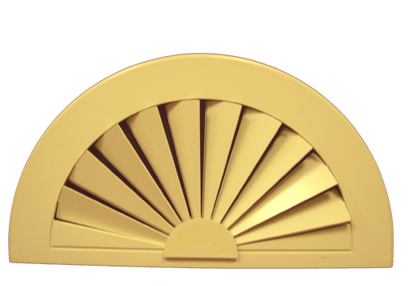
14-day production period.

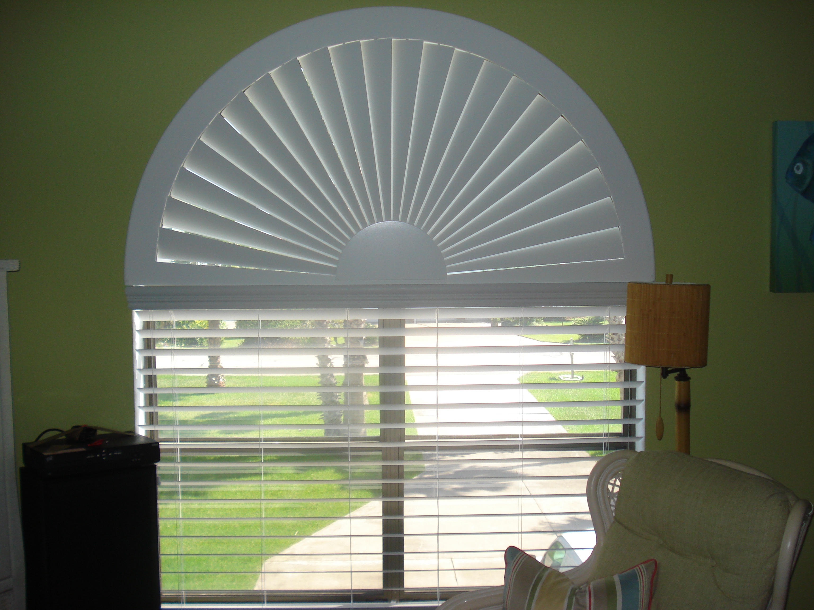
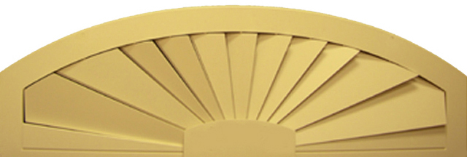

Movable individual overlapping slats
Outside mounted of window opening only
A wood product, not plastic, can be repainted at an additional cost
Several types and sizes to choose from, all arches are manufactured with quality shutter hardware
Distinguished “one of a kind” frame with a unique center support and decorative beveled edge
Offered in American white and off-white colors to complement any décor
One dimensional engraved frame and design on front of flat arch panel

E-Series Stock Non-Movable Arches and Eyebrows
One dimensional engraved frame and design on front of flat arch panel)
EG (E-Series Grooved) 1/4" openings between engraved Slats
EO (E-Series Opaque) 1/4" openings between engraved Slats not completely cut through
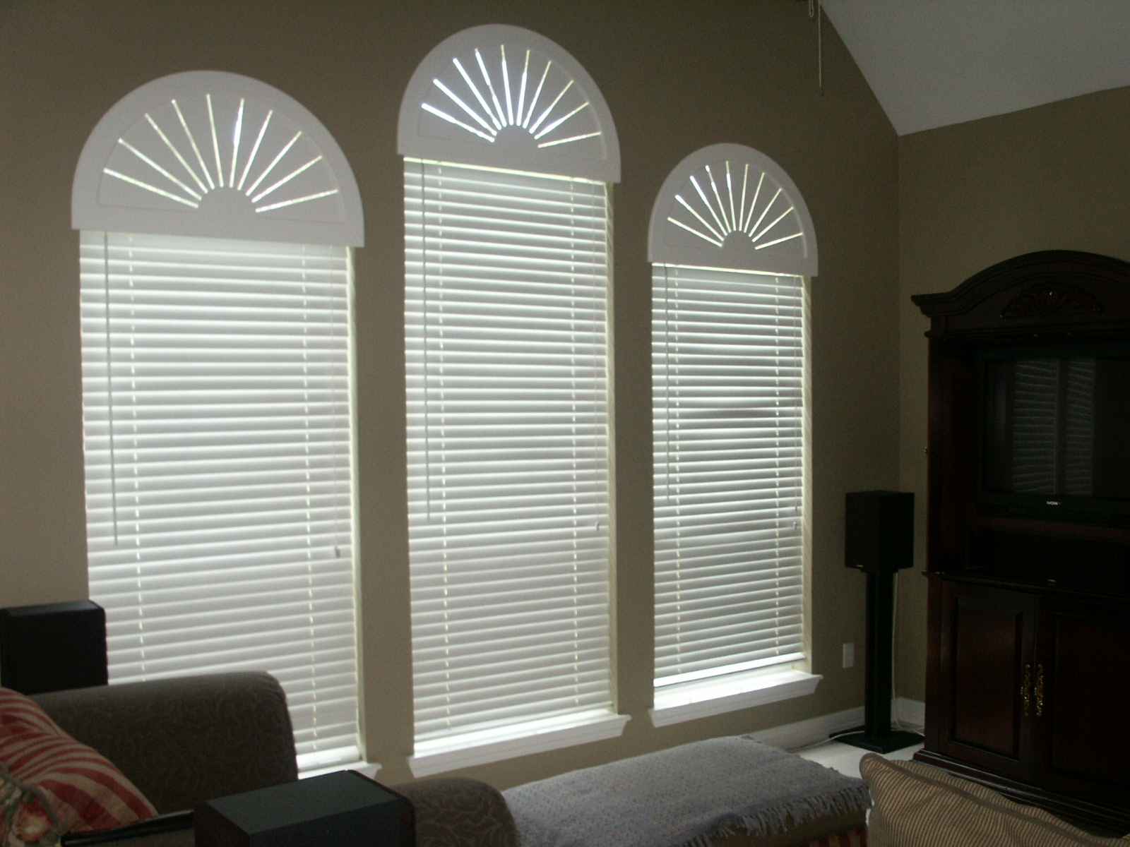
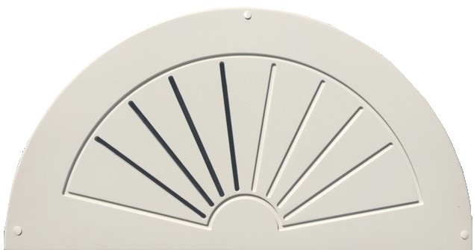
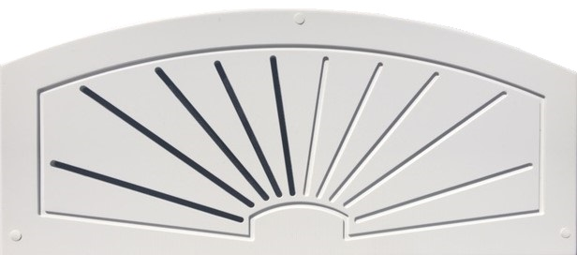

Sample Cases
SK-19
Custom Sample
This lightweight Sample includes our Custom non-movable Sunburst, Slatburst, Blackout and Operable Styles with an outside mounted and inside mounted frame with mounting strip
SK-20
Stock Sample
This lightweight Sample includes our King Stock Movable Arch and our E-Series Stock Non-Movable Arches, EO and EG

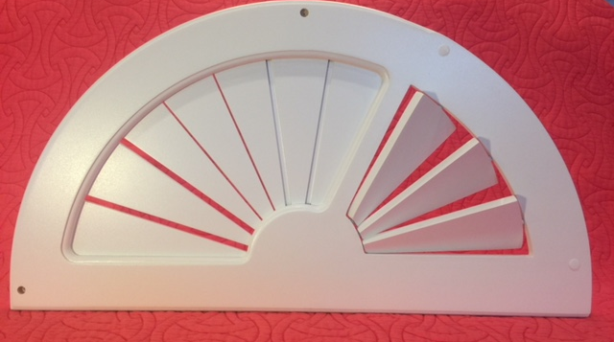
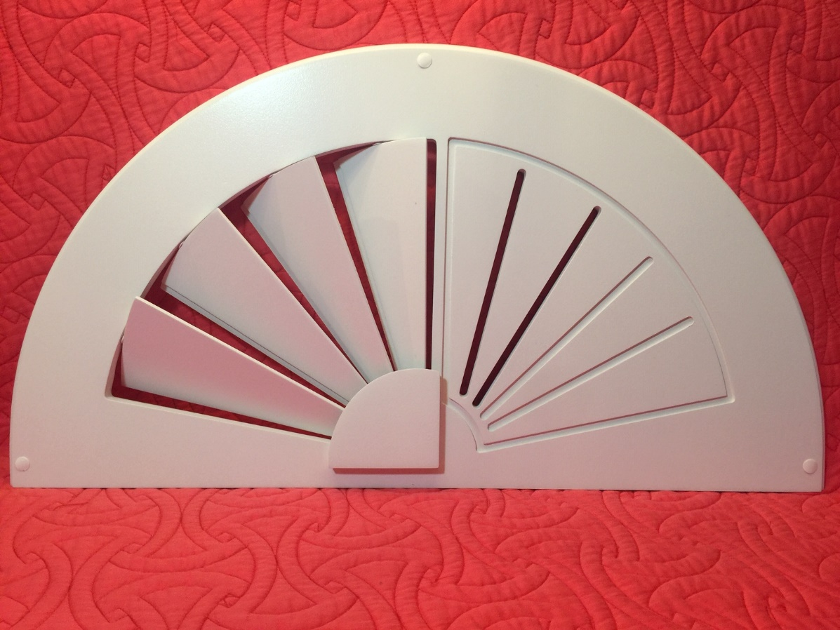
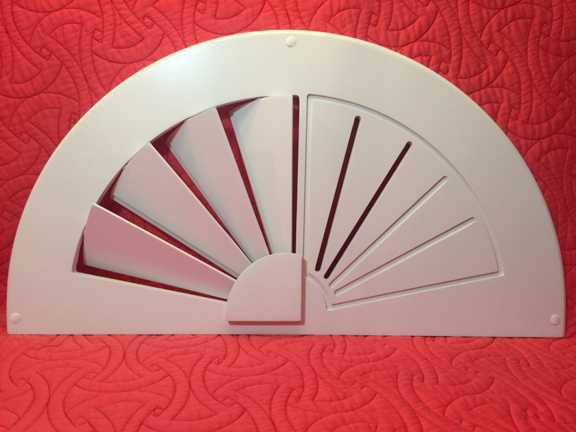
www.americanarches.com
281-955-6779

