Stock Sample Kit
SK-20
Light Weight

Our new one-piece Stock Sample Kit showcases the King Stock Movable Arches and the New Stock E-Series Non-Movable Styles. This 24” x 12” Stock Sample Kit represents our stock products that are outside mounted only.
For Stock Sizes and Specifications see americanarches.com Stock Products/Specifications
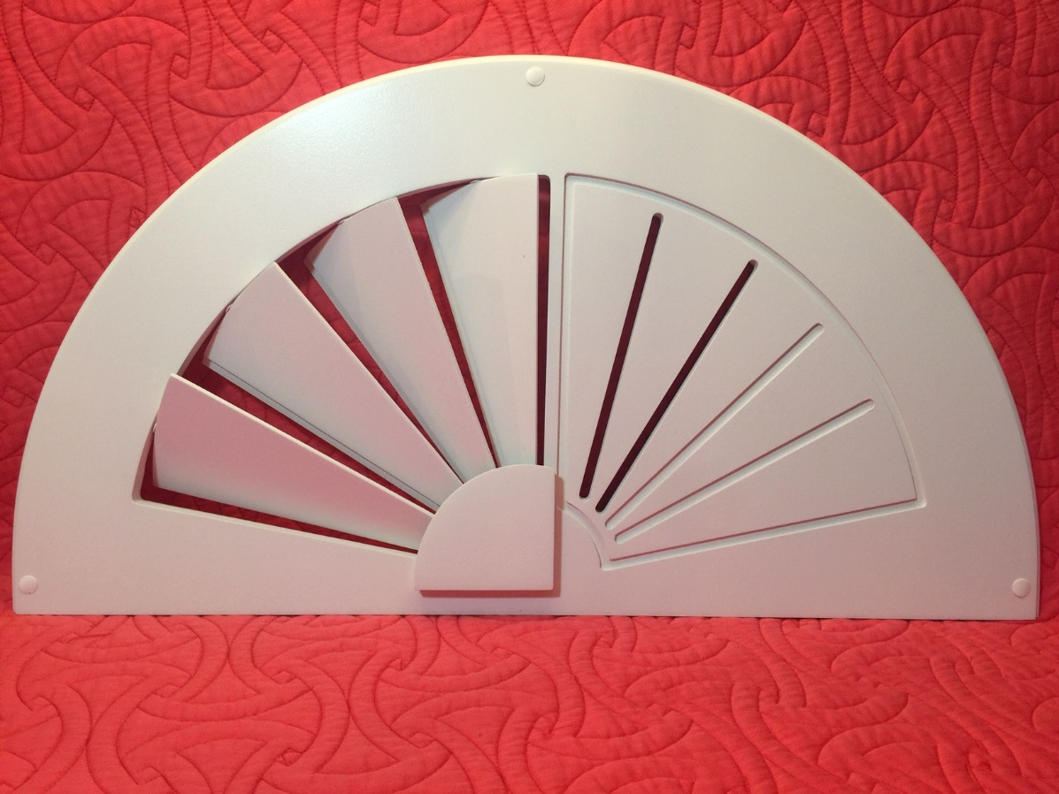
E-Series Stock
Non-Movable
Offered in two Styles

Sample Case for Custom Products
Also available
SK-19
King Stock
Movable
Slats
(overlap Design)
EO
Opaque
¼” grove not cut through
EG
Grooved
¼” Grove cut completely
through
American Arches
11269 Windfern Rd. Houston, Tx 77064
Americanarches.com
281-955-6779

